Gallery TS1 Artistic Director

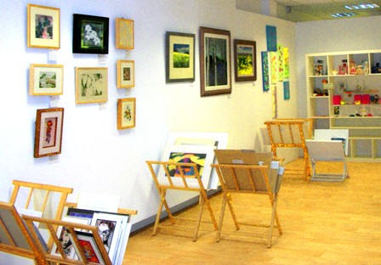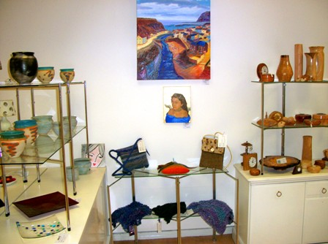

Gallery TS1 (GTS1) is a dedicated gallery space in Middlesbrough exhibiting and selling fresh and affordable arts and crafts by emerging and established local creatives, and is located at 57 Corporation Road, Middlesbrough.
As part of a new re-launch strategy, GTS1 is offering an exciting opportunity to someone who wishes to build up their profile in the arts and crafts curation field.
- This is a voluntary, unpaid role, equivalent to 1 day a week on average.
- The appointment will be for a year from 1st April 2015 – 31 March 2016
The successful candidate will work alongside and be supported by the existing team of curators with the aim of producing 4 exhibitions over the year. The exhibitions will feature work by both GTS1 members and non-members and the Director will participate in the organisation and delivery of these.
In between these public exhibitions the Artistic Director will coordinate exhibitions featuring work by GTS1 members and also facilitate the letting of the Gallery’s exhibition space to other artists and organisations.
In addition, GTS1 has the potential to undertake occasional community projects and it is expected that the Artistic Director will assist in the development of this together with the GTS1 management committee.
The Artistic Director post at GTS1 would suit someone who is:
- Passionate about the arts
- Organised and confident
- A great communicator
And in return, a role within our team would:
- Offer you valuable work experience
- Broaden your knowledge of the arts sector
- Enhance your CV
- Extend your professional network
If you are interested in applying for this post, please submit a letter of application outlining why you think you are suitable for the position and how you see yourself developing the role, together with your CV to infogalleryts1@btopenworld.com by Friday 6th March 2015. Interviews will take place during wc 16th March.

